**User Manual**

**Module - Retail Billing System (Sales Manager)**

**June 2022, Version-1.0**



**Sustainable Outreach and Universal Leadership Limited**

**Sign off Date     Signature Client Signature Consulting**

Table of Contents 2

Module: Retail Billing System 3  
1.Settings & Configuration 4-8

1.1 Point Of Sale Profile 8  
1.2 Point Of Sale Setting 8

2.Loyalty Program 9-13

2.1 Loyalty Program 11

2.2 Loyalty Program Entry 13

3.Opening & Closing 13-15

3.1 POS Opening Entry 13

3.2 POS Closing Entry 14

4. Reports 15

4.1 Salesman Wise Sales Report 15

4.2 Sales Invoice Report 15

5. Point Of Sale 16-20

6. Masters 21-36

6.1 Customers 21

6.2 Items 28

6.3 Item Price 29

6.4 Pricing rule 31

6.5 Warehouse 32

6.6 Accounts Tree 34

6.7 Sales Invoice 36

**Module: Retail Billing System**

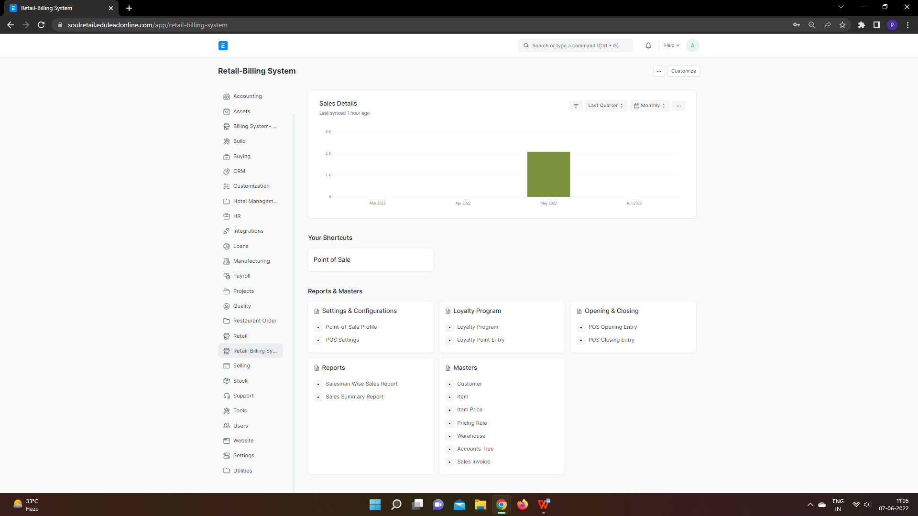

# **Settings & Configuration**

# **1.1 Point of Sale Profile**

**A POS profile allows using the Point of Sale feature.**

POS includes advanced features to cater to different functionality, such as inventory management, CRM, financials, warehousing, etc., all built into the POS software. Before modern POS, all of these functions were done independently and required the manual re-keying of information, which could lead to entry errors.

If you are in retail operations, you want your Point of Sale to be as quick and efficient as possible. To do this, you can create a POS Profile for a user.

To access the POS Profile list, go to:

Home > Retail-Billing System > Reports & Masters > Settings & Configurations > Point of Sale Profile

**List View of All POS Profiles:**

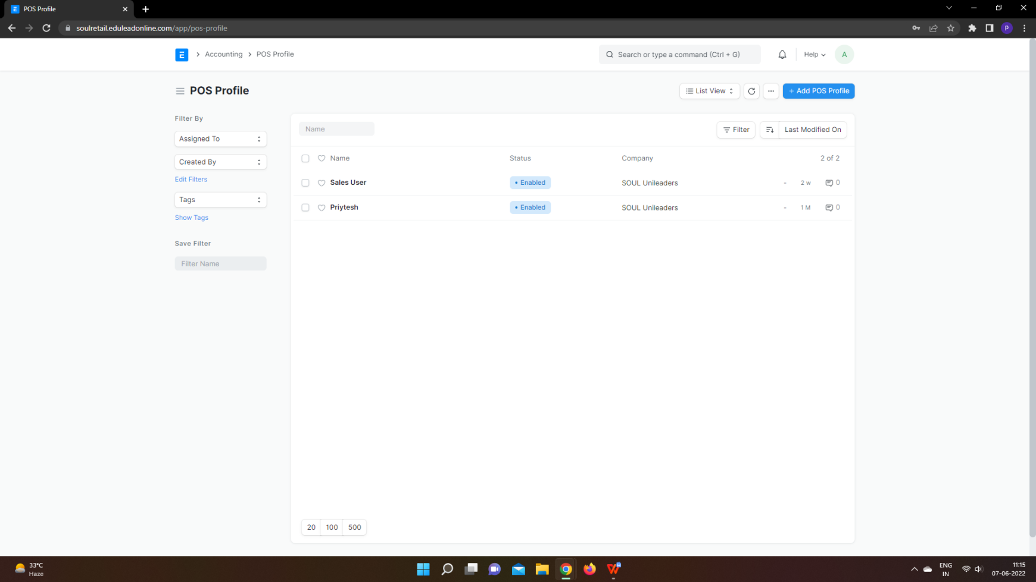

**Doctype View of POS Profile**

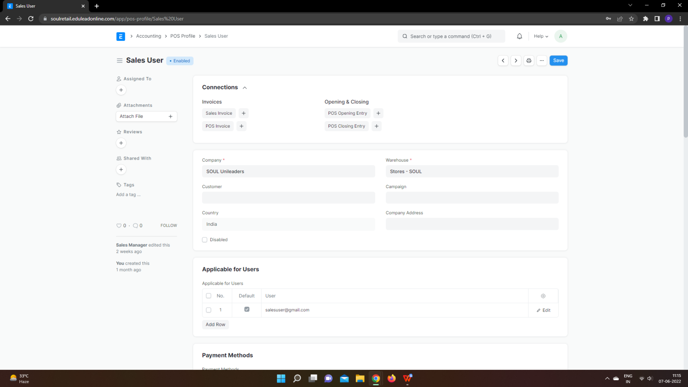

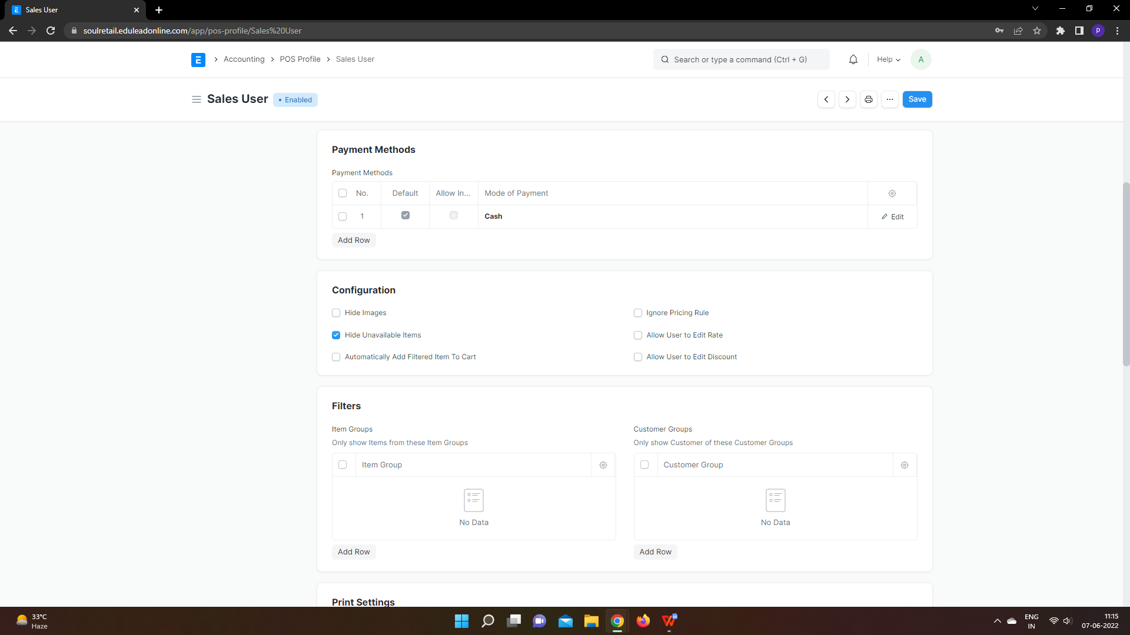

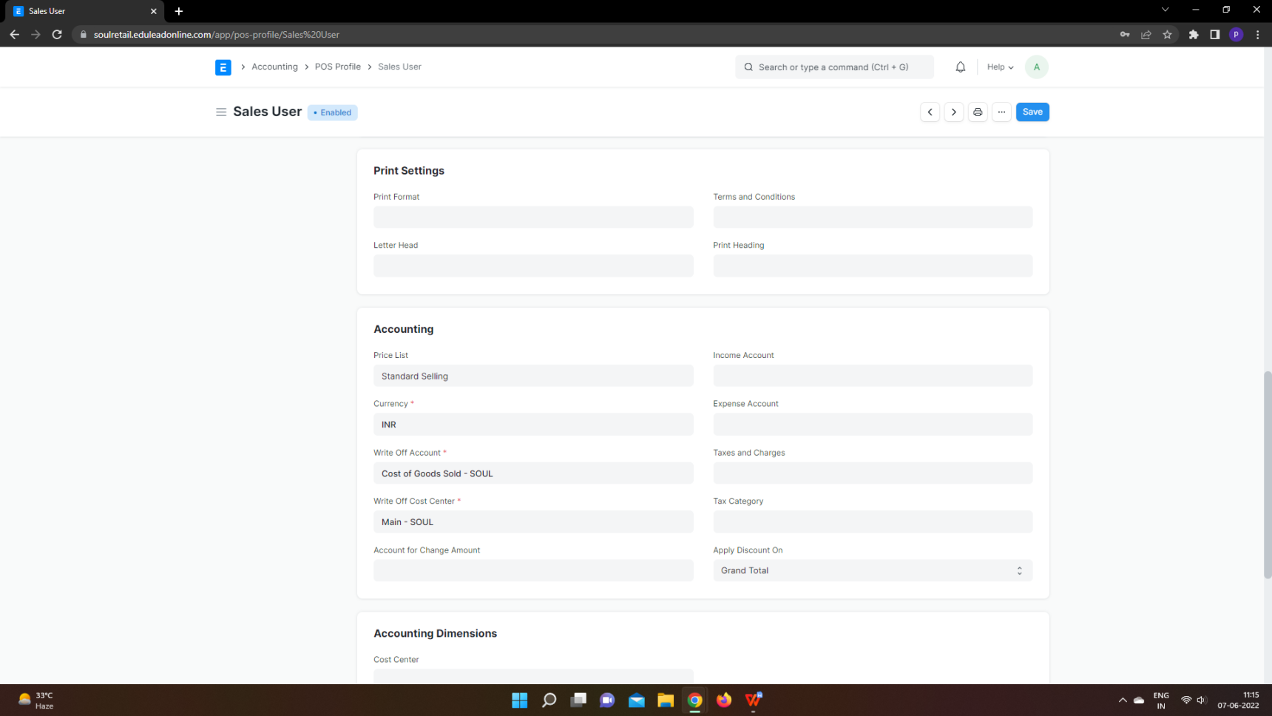

## **1.1.1 How to create a POS Profile**

1. Go to the Point-of-Sale Profile and click on New.
2. Enter a name for the profile.
3. Select a [Naming Series](https://docs.erpnext.com/docs/v13/user/manual/en/setting-up/settings/naming-series).
4. Set a Write Off Account and Write Off Cost Center to which the transactions will be recorded.
5. Set up payment modes in the table, the default will be cash if nothing is set here. Only the modes set here will be available when using POS. After adding payment modes, set one of them as the default payment method by ticking the checkbox.
6. Set the default amounts for the payment methods (recommended: 0).
7. Save.

### 1.1.2 **Additional options when creating a POS Profile**

* ****Customer****: Users can sell particular products to the particular Customers from the POS by adding item groups, customer groups in the POS Profile.
* ****Warehouse****: The stock quantities in the selected Warehouse will be affected for POS transactions with this POS Profile.
* ****Campaign****: A sales Campaign can be linked here to track total sales against it.
* ****Company Address:**** If the POS counter is set up at a Company branch, the address can be selected here.
* ****Update Stock****: If enabled, the stock quantities will be affected when transactions are performed with the POS Profile. That is, Stock Ledger Entries will be made when you “Submit” this Sales Invoice thereby eliminating the need for a separate Delivery Note.
* ****Ignore Pricing Rule****: Any active Pricing Rule will be ignored for this POS Profile.
* ****Allow Delete****: In Offline POS, the data is cached. Ticking this checkbox will allow User to delete the Sales Invoice cached in the Draft stage.
* ****Allow user to edit Rate****: The POS Profile user will be allowed to edit the 'Rate' of Items added in transactions.
* ****Allow user to edit Discount****: The POS Profile user will be allowed to edit the 'Discount' of Items added in transactions.
* ****Allow Print Before Pay****: This will allow the POS User to print an invoice before the payment is made.
* ****Display Items In Stock****: The remaining quantity of Items from the selected Warehouse will be shown to the POS User.

**1.1.3 Features**

### 1.1.3.1 **Applicable for Users**

By default, all Sales Users can access the POS Profiles created in ERPNext. However, if you want only certain Users to access certain POS Profiles, you can add them to the table. Once even one User is set in the POS Profile, other Users cannot use this POS Profile for retail transactions.

****Setting POS Profile as default****: On ticking the Default checkbox in the table, the current POS Profile becomes the default POS Profile for that User. So, the next time the User logs into the system, the POS Profile will be set by default.

### 1.1.3.2 **Print Settings**

#### **Print Format for Online**

You can set a Print Format which will decide what the layout of the printed document will look like. To know more, visit the [Print Format](https://docs.erpnext.com/docs/v13/user/manual/en/setting-up/print/print-format) page.

#### **Letterhead**

You can print your POS Sales Invoice on your Company's letterhead. Know more [here](https://docs.erpnext.com/docs/v13/user/manual/en/setting-up/print/letter-head).

#### **Print Headings**

POS Sales Invoice headings can also be changed when printing the document. For example, the heading can be 'Invoice', or 'Bill'. You can do this by selecting a ****Print Heading****. To create new Print Headings go to: Home > Settings > Printing > Print Heading. Know more [here](https://docs.erpnext.com/docs/v13/user/manual/en/setting-up/print/print-headings).

#### **Terms and Conditions**

There may be certain terms and conditions on the Item you're selling, these can be applied here. To know about adding Terms and Conditions, click here.

### 1.1.3.3 **Accounting**

* ****Price List****: A Price List stores the Item Prices. Setting a Price List here will fetch the Item Prices for the current POS Profile from that Price List.
* ****Currency****: By default, this will be set according to the Company's default currency. However, you can change it. In case you change the currency, remember to change the accounts too.
* ****Taxes and Charges****: Selecting a Sales Taxes and Charges Template or Purchase Taxes and Charges Template here will automatically apply the taxes and charges to the POS transaction.
* ****Apply Discount On****: Here you can set whether the discount is to be applied on the Grand Total (pre tax amount) or the Net Total (post tax amount).
* ****Tax Category****: On selecting a [Tax Category](https://docs.erpnext.com/docs/v13/user/manual/en/accounts/tax-category) here, the Tax Rules associated with the Tax Category will be applied to each transaction performed from this POS Profile.

The following accounts can be set so that the general ledger is updated accordingly:

* Account for Change Amount
* Write Off Account
* Write Off Cost Center
* Income Account
* Expense Account

### 1.1.3.4 **Accounting Dimensions**

Accounting Dimensions lets you tag transactions based on a specific Territory, Branch, Customer, etc. This helps in viewing accounting statements separately based on the criteria selected. To know more, visit the Accounting Dimensions page.

**1.2. POS Setting**

Using POS Setting we can set POS Fields and also POS Search Fields that would reflect in POS Screen.

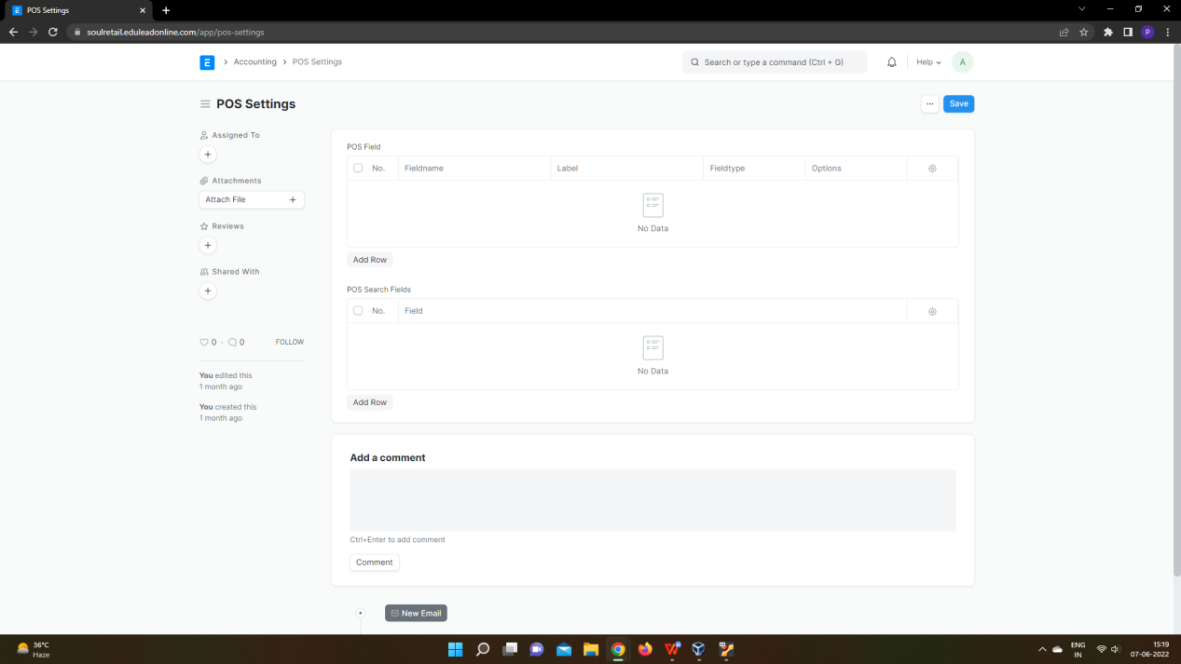

**1.2.1 To access the POS Setting, go to:**

Home > Retail-Billing System > Reports & Masters > Settings & Configurations > POS Settings

**1.2.2 How to set POS Settings**

1. Go to the POS Setting setting.
2. Click on Add Row at the bottom of the table of POS Field.
3. In POS fields select the name of the fields that you want to add in POS screen the respective labels, Fieldtypes and Options will be fetched automatically.
4. Similarly in case of POS Search Fields, Select Field that you want to appear in POS for search the records that would be generated.
5. Save
6. **Loyalty Program**

**2.1 Loyalty Program**

**A Loyalty Program allows Customers to earn points by spending a certain amount and lets them redeem the points in future purchases.**

A Customer Loyalty Program is a structured and long-term marketing effort that provides incentives to repeat Customers. Successful programs are designed to motivate Customers in a business's target market to return often, make frequent purchases, and shun competitors.

To access the Loyalty Program list, go to:

Home > Retail-Billing System > Reports & Masters > Loyalty Program > Loyalty Program

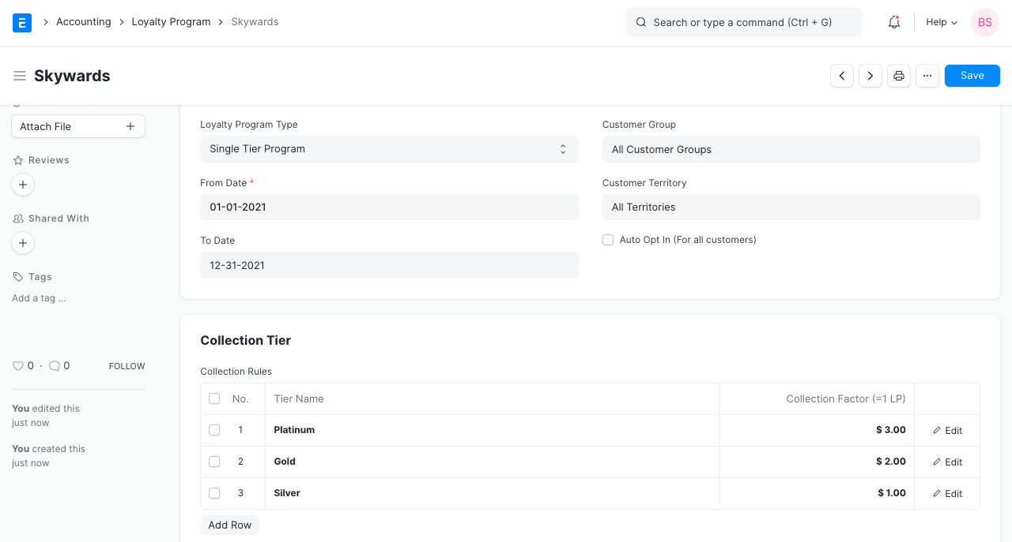

## **Prerequisites**

Before creating and using a Loyalty Program, it is advised to create the following first:

1. Customer
2. Sales Invoice

## **How to Create a Loyalty Program**

1. Go to the Loyalty Program list and click on New.
2. Enter a Name for the Loyalty Program.
3. Select whether the program is Single Tiered or Multi Tiered (gold, silver, etc).
4. Set a start and end date for the program.
5. Select the Customer Group and Territory for which this program is applicable, the default is all.
6. For opting in all Customers by default, tick on 'Auto Opt In (For all customers)'. Otherwise, the program needs to be assigned from the Customer master.
7. In the table, enter:
   1. ****Tier name****: To be assigned to a Customer based on his eligibility.
   2. ****Collection Factor****: How much amount needs to be spent to gain 1 Loyalty Point in ERPNext.
   3. ****Minimum Amount****: Minimum amount to be spent to qualify into a tier.
8. Set the Conversion Factor, eg: 10 USD = 1 point.
9. Save.

### **Redemption section**

****Conversion Factor****: When redeeming loyalty points, this factor decides how much money is 1 Loyalty Point worth. For example, if a Customer has 100 Loyalty Points, and 1 Loyalty Point = 1 USD, then the Customer use Items up to 100 USD with their loyalty points for future purchases.

****Expense Account****: Set an Expense Account from where you'll offer the benefits. This is useful to track the benefits offered separately.

****Expiry Duration (in days)****: The collected loyalty points will expire after the number of days set in this field.

### **Loyalty Points in Customer**

Set a Loyalty Program section in the Customer master to assign a Loyalty Program to a Customer.

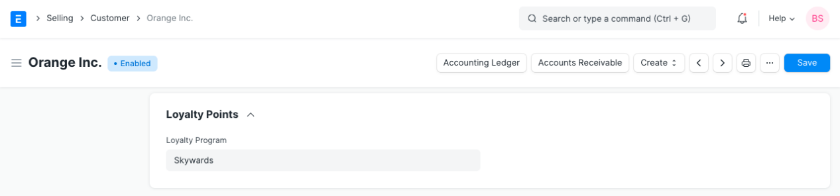

****Loyalty points**** earned can be viewed in the Customer's dashboard.

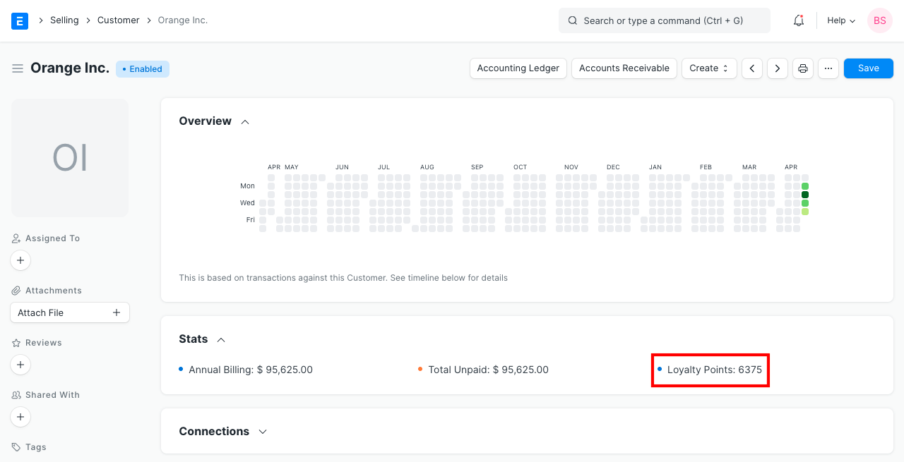

### 2.2. **Loyalty Point Entry**

To access the Loyalty Program list, go to:

Home > Retail-Billing System > Reports & Masters > Loyalty Program > Loyalty Program Entry

This acts as a log to give an overview of which Customer earned how many points against which Sales Invoice. It holds the data Invoice and Customer.

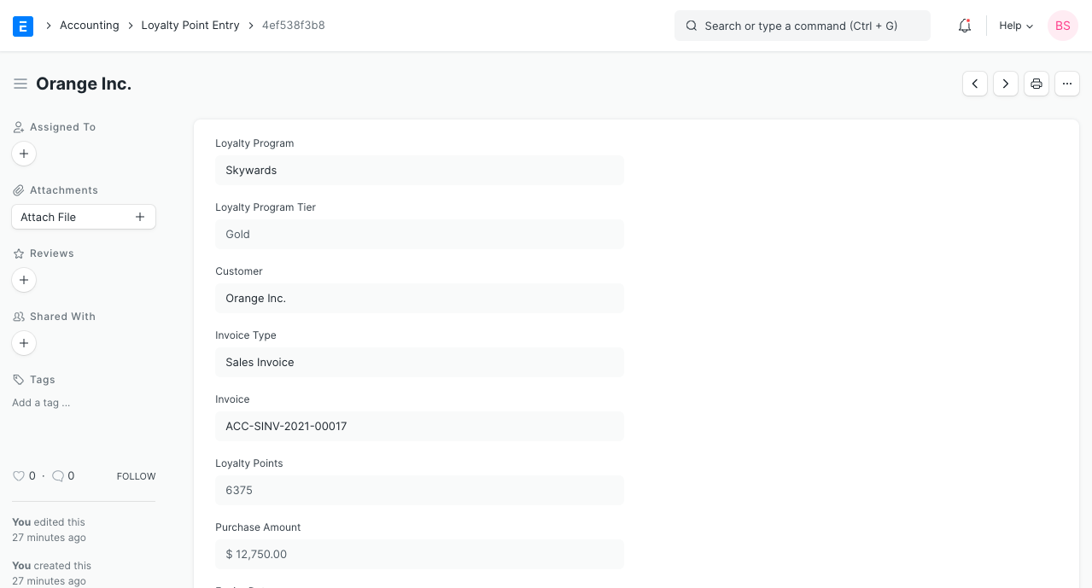

## 2.2.1 **How does a Loyalty Program work?**

### **2.2.1.1 Earning Points**

* Firstly, a ****Loyalty Program**** needs to be created as explained in the first section.
* Assign this ****Loyalty Program**** to a ****Customer****.
* Create a new Sales Invoice for the ****Customer**** to whom you have assigned ****Loyalty Program****.
* For this example, an invoice is created with a grand total of 3,000 INR and according to the ****Loyalty Program**** for a minimum spent of 2,000 INR, the Silver Tier collection factor will be eligible and for each 300 INR spent, the ****Customer**** will receive 1 point (hence the total points earned on this transaction is 15).
* Upon submission of the invoice, a ****Loyalty Point Entry**** will be created for this invoice (as shown above under Loyalty Program Entry section).
* In our ****Loyalty Program**** upon minimum spent of 6,000, Gold Tier would be eligible. So, when another invoice is submitted with the same value, the total sales from this Customer becomes 6,000. So now, the ****Customer**** will be automatically upgraded to the Gold tier.

### 2.2.1.2 **Redeeming Points**

* Let's continue from the above example where we created 1 invoice and earned 15 points from it. When creating another invoice for the same Customer, go to the Loyalty Points section and enable the checkbox to 'Redeem Loyalty Points'.

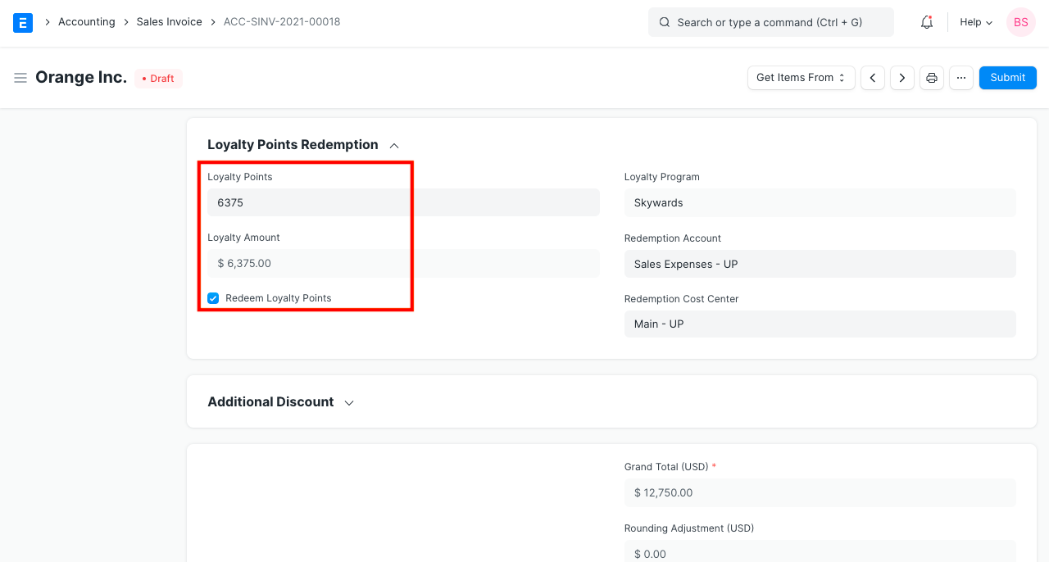

* The fields for 'Loyalty Point', 'Redemption Account' and 'Redemption Cost Center' will become visible under this section. The account and Cost Center will be fetched from the ****Loyalty Program**** assigned to the ****Customer****.
* Since the Customer has earned 15 points, we can use all of it until expiry. If we try to use more than what we have an error will be thrown.
* In above example, we have used 6375 points to be redeemed. Doing so will enable another field that will display the amount calculated using (loyalty point * Conversion Factor). So, USD 6375 will be deducted from our the amount since our 'Conversion Factor' was '1'.
* When submitted, 2 ****Loyalty Point Entries**** will be created. One for redeemed, which will be a negative value and one for the current invoice.

**3.Opening & Closing**

**3.1 POS Opening Entry**

Before the start of the day, the admit will create a POS for any cashier by creating a POS Opening Entry.

**To access the POS Opening Entry, go to:**

Home > Retail-Billing System > Reports & Masters > Opening & Closing > POS Opening Entry

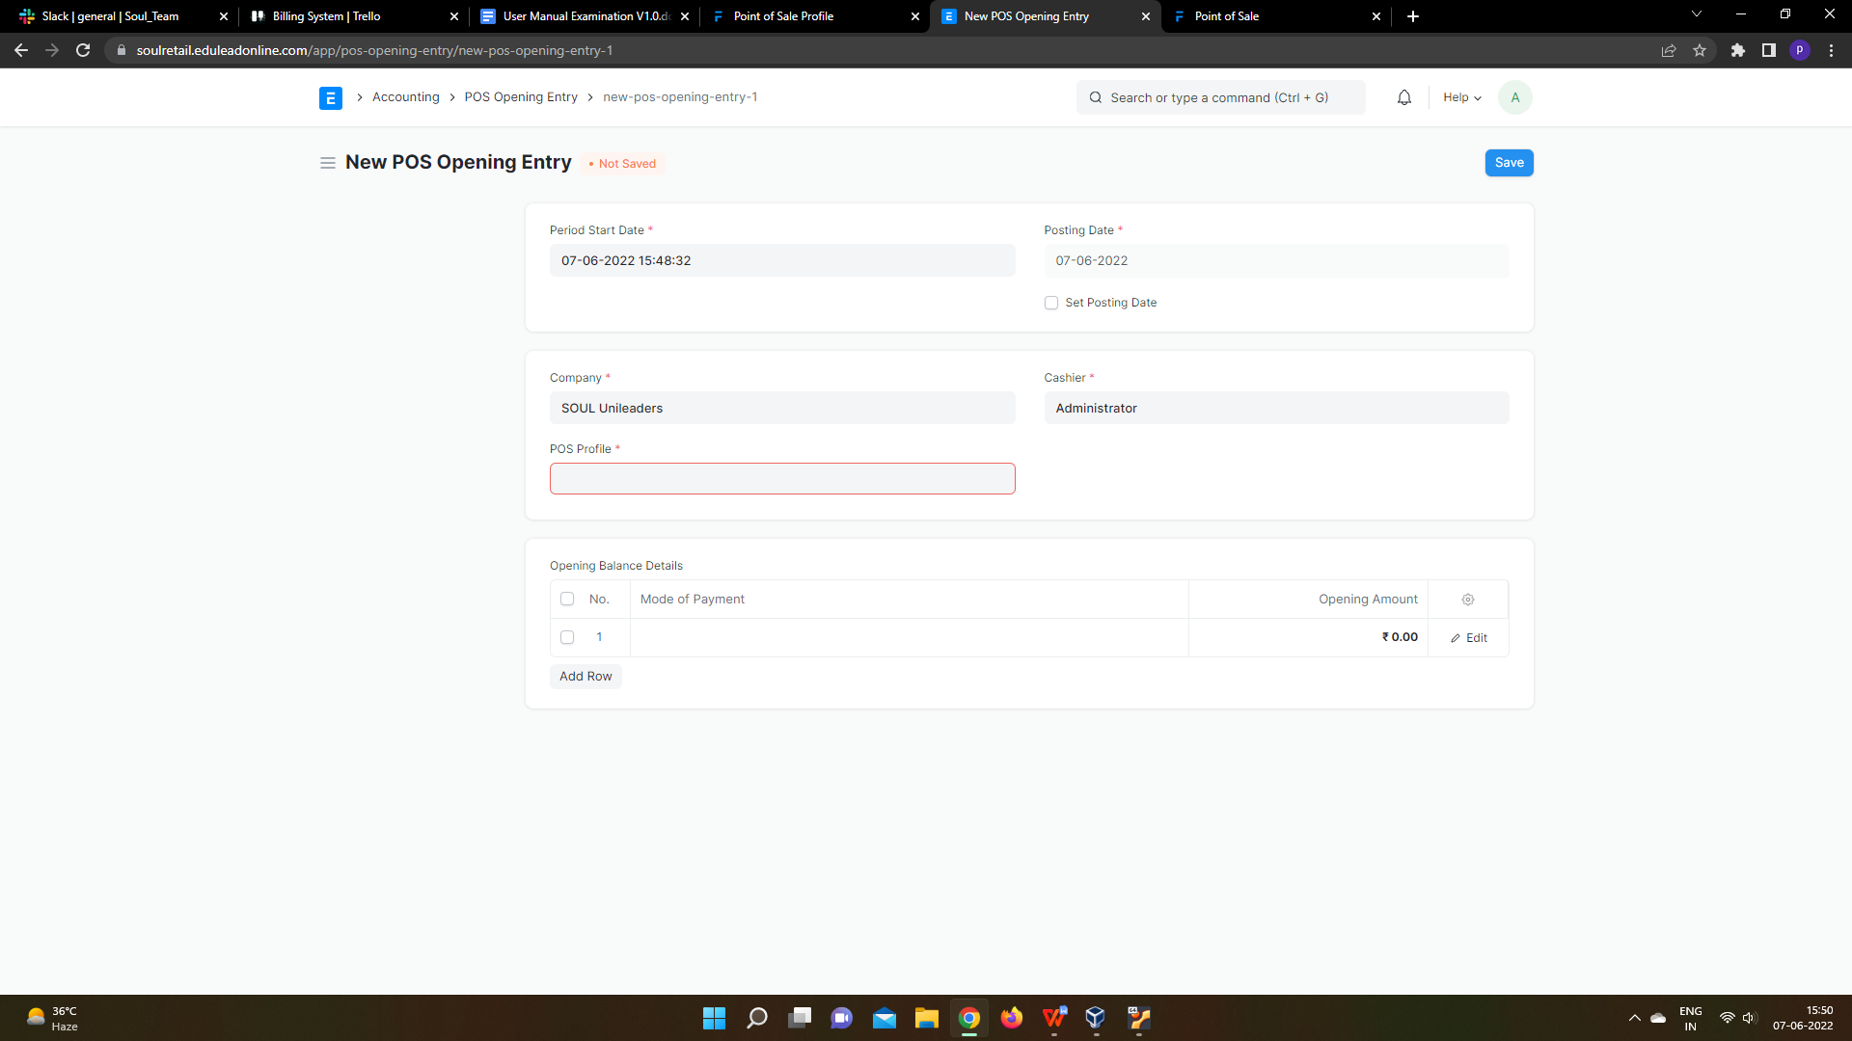

**How to create a POS Opening Entry**

1. Go to the POS Opening Entry Page and Click on Add POS Opening Entry.
2. Select Period Start Date, Posting Date if you want to change the posting date, Cashier and POS Profile.
3. Select Mode of payment and enter Opening amount.
4. Click Save.

### 3.2 **POS Closing Voucher**

At the end of the day, the cashier can close his/her PoS by creating a POS Closing Voucher.

**To access the POS Opening Entry, go to:**

Home > Retail-Billing System > Reports & Masters > Opening & Closing > POS Closing Entry



**How to create a POS Opening Entry**

1. Click on the Menu and select 'Close the POS'.
2. Select the period, your POS Profile and your user to retrieve all sales registered. At the end of the day, the cashier can close his/her shift by creating a POS Closing Voucher.
3. Click on the Menu and select 'Close the POS'. Select the period, your POS Profile and your user to retrieve all sales registered.

On creating a POS Closing Voucher, all the POS invoices fetched for the selected period will be consolidated into one final Sales Invoice. The status of all the POS invoices will change from 'Paid' to 'Consolidated' once they are successfully consolidated into a sales invoice on closing.

If there are more than 10 invoices while closing a POS, consolidation of the invoices will take place in a background job and would be subitted after the background job gets completed. The Accounting Ledgers would be affected only after the Closing Voucher is submitted successfully and the consolidated sales invoices are created.

1. **Reports**

**4.1 Salesman Wise Sales Report**

Using Salesman Wise Sales Report you can view Salesman Wise Sales report of individual Salesman registered in the system that how much sales they have done in any particular day, week, month, year, etc.

**To access the Salesman Wise Sales Report, go to:**

Home > Retail-Billing System > Reports > Salesman Wise Sales Report

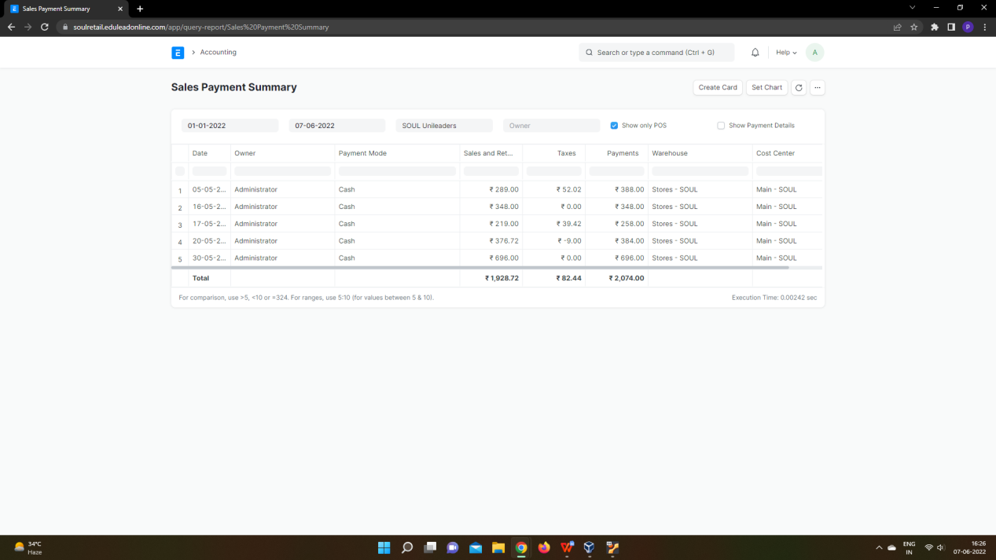

**4.2 Sales Invoice Report**

In Sales Invoice report you can view sales report for all the sales in the time selected between the dates that you have selected. The details of all those transactions would be fetched Like Sales Invoice ID, Customer details associated with the sales invoice, status of the invoice.

**To access the Salesman Wise Sales Report, go to:**

Home > Retail-Billing System > Reports > Sales Invoice Report

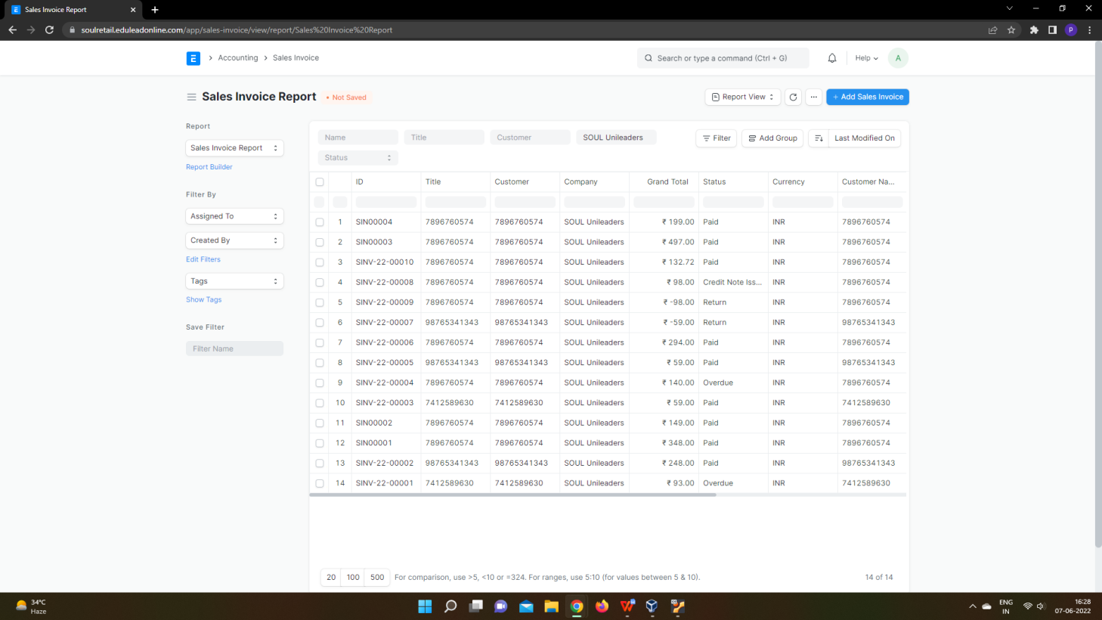

1. **Point Of Sale**

**A Point of Sale refers to the time and place where a retail transaction takes place.**

For retail operations, the delivery of goods, accrual of sale and payment all happens in one event, that is usually called the 'Point of Sale' (POS).

In ERPNext Sales Invoices can be generated from the POS. There are two steps to set up POS:

To access POS, go to:

Home > Retail-Billing System > Your Shortcuts > Point of Sale

## **5.1 Prerequisites**

Before creating and using Point of Sale, it is advisable to create the following first:

* [POS Profile](https://docs.erpnext.com/docs/v13/user/manual/en/accounts/pos-profile)

## **5.2 How to create a POS Invoice**

Once you set up a POS profile, you can start billing on POS.

1. Go to POS and select a Customer.
2. Add Items from the list displayed on the right by clicking on them.
3. Ensure that the Item has a Selling Price set in the Item Price list.
4. Edit the quantities as needed.
5. In order to edit Rate and Discount, you need to enable them in the POS Profile.
6. A default Warehouse needs to be set to complete the transaction. If Warehouse is set in both Item and POS profile, the one in POS Profile will be given preference.
7. Do note that you need to have Items in your Warehouse before you can sell. If Items are not available, a red dot will be shown next to the Item when selected.

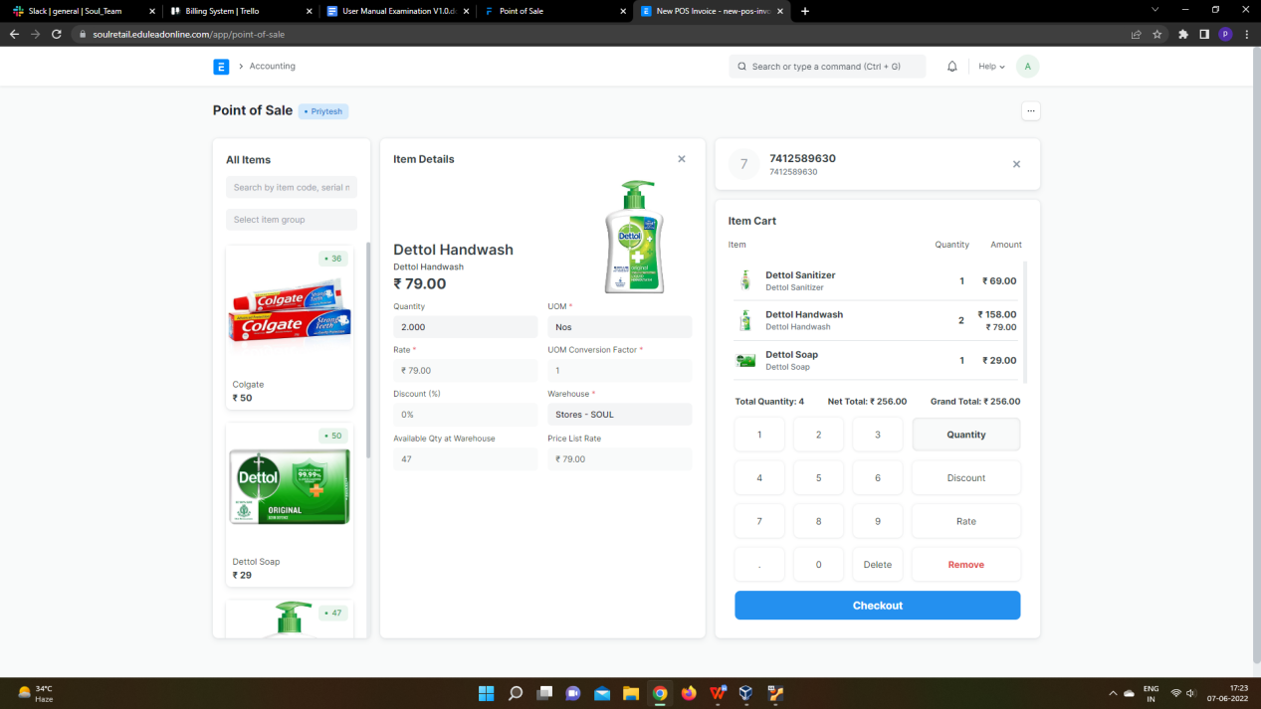

1. When all Items are added, cross check the net and grand totals and also the total quantity in the summary at the bottom.
2. Select the payment mode and click on Complete Order. You'll be asked to submit the Sales Invoice.
3. You can then print the POS invoice.

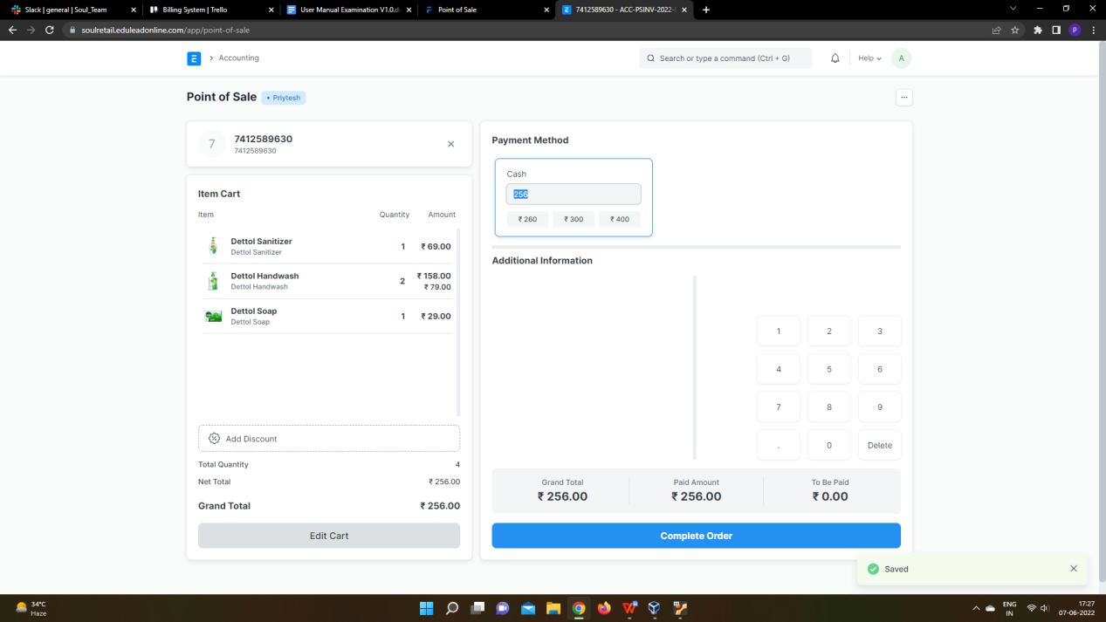

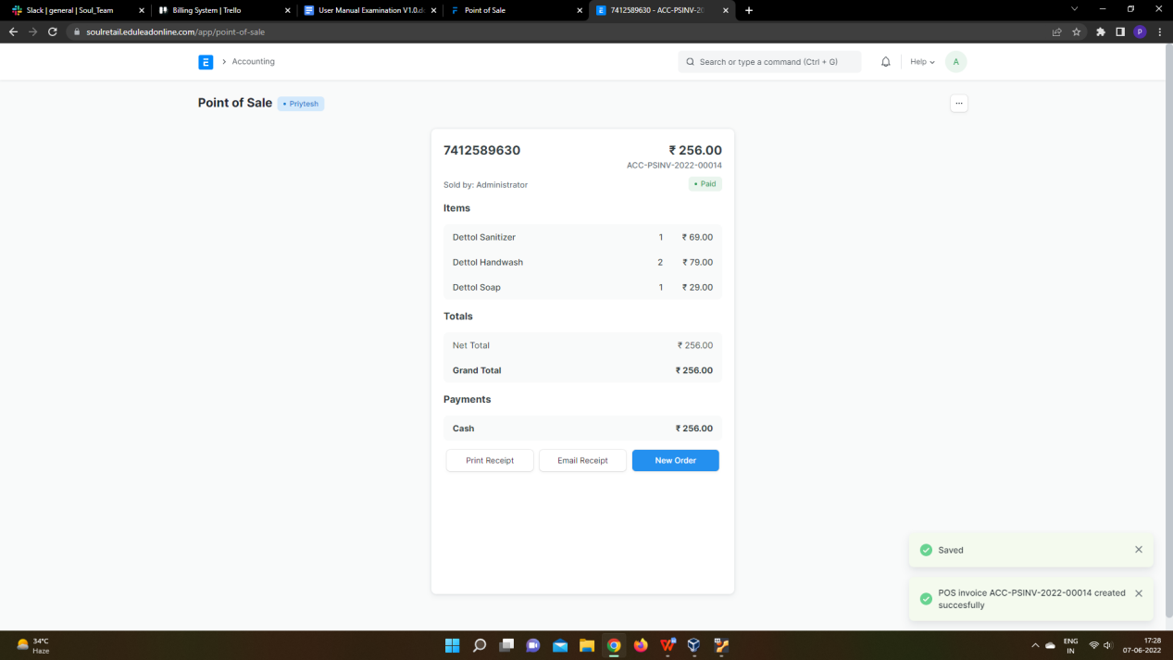

After the Sales Invoice is submitted, you can either print or email it directly to the customer.

### **5.3 Adding an Item**

At the billing counter, the retailer needs to select Items which the Customer buys. In the POS interface you can select an Item by two methods. One, is by clicking on the Item image and the other, is through the Barcode / Serial No.

1. ****Select Item****: To select a product click on the Item image and add it into the cart. A cart is an area that prepares a customer for checkout by allowing to edit product information, adjust taxes and add discounts.
2. ****Barcode / Serial No****: A Barcode / Serial No is an optical machine-readable representation of data relating to the object to which it is attached.
3. Enter Barcode / Serial No in the box as shown in the image below and pause for a second, the item will be automatically added to the cart.

### **5.4 Removing an Item from the Cart**

1. Select row in the cart and click on 'Remove' button in the numeric keypad
2. Set Qty as zero to remove Item from the POS invoice. There are two ways to remove an Item.
3. If Item's Qty is 1, click on a minus sign to make it zero.
4. Manually enter 0 (zero) quantity.

### **5.5 Change Amount**

POS calculates the extra amount paid by the customer, which user can return from the cash account. User has to set the account for the change amount on the POS profile.

## **5.6 Features**

### **5.6.1 Adding a new Customer**

In POS, user can select the existing Customer during making an order or create a new customer. This feature works in the offline mode also. User can also add the customer details like contact number, address details, etc on the form. The Customer which has been created from the POS will be synced when the internet connection is active.

### **5.6.2 Accounting entries (GL Entry) for a Point of Sale:**

Debits:

1. Customer (grand total)
2. Bank/Cash (payment)

Credits:

1. Income (net total, minus taxes for each Item)
2. Taxes (liabilities to be paid to the government)
3. Customer (payment)
4. Write Off (optional)
5. Account for Change Amount (optional)

To see entries after submitting the [Sales Invoice](https://docs.erpnext.com/docs/v13/user/manual/en/accounts/sales-invoice), click on ****View Ledger****.

### **5.6.3 Email**

You can also send the receipt via email.

### **Create Return Credit Note**

You can also create a return credit note against a POS Invoice in case of return of items or the entire order. Below are the steps for issuing a credit note against an invoice:

1. Click on menu (3 dots) and then click on ****Toggle Recent Orders****.
2. All the invoices from recent POS transactions will be displayed under the ****Recent Orders**** pane. You can either search for the invoice directly with its name or filter search results as per the status of the invoice which can be ****Paid, Consolidated, Draft, Return****.
3. Select the invoice against which you need to create the credit note after which you will see the invoice details and the options to Print, Email the receipt and an option to make a Return. Click on ****'Return'****.
4. The POS screen will display the items in the invoice, along with respective negative quantities and totals in the Item Cart which indicates that it is a return credit note.
5. Once you checkout, you'll see the Grand Total, Paid Amount and Taxes too if applicable.
6. Clicking on ****Complete Order**** will complete the process and create the final return credit invoice and display the bill on the screen like a normal order.

**6.Masters**

### **6.1 Customer**

**A customer, who is sometimes known as a client, buyer, or purchaser is the one who receives goods, services, products, or ideas, from a seller for a monetary consideration.**

Every customer needs to be assigned a unique id. Customer name itself can be the id or you can set a naming series for ids to be generated in [Selling Settings](https://docs.erpnext.com/docs/v13/user/manual/en/selling/selling-settings).

To access the Customer list, go to:

Home > Retail-Billing System>Reports & Masters > Masters > Customers

## **6.1.1. How to create a Customer**

1. Go to the Customer list and click on New.
2. Enter Full Name of the customer.
3. Select Individual if the customer represents an individual or Company if the customer represents a company in Type field.
4. Select a Customer Group. Individual, Commercial, Non Profit and Government are available by default. You can create additional groups if you need.
5. Select the Territory.
6. If the customer is being created against a lead, you can select the same in From Lead field.
7. Save.

**6.2 Item:**

**An Item is a product or a service offered by your company.**

The term Item is also applicable to raw materials or components of products yet to be produced (before they can be sold to customers). ERPNext allows you to manage all sorts of items like raw-materials, sub-assemblies, finished goods, item variants, and service items.

ERPNext is optimized for itemized management of your sales and purchase. If you are in services, you can create an Item for each service that you offer. Completing the Item Master is very essential for the successful implementation of ERPNext.

To access the Item list, go to:

Home > Retail-Billing System>Reports & Masters > Masters > Item

## **6.2.1. Prerequisites**

Before creating and using an Item, it is advised that you create the following first:

* [Item Group](https://docs.erpnext.com/docs/v13/user/manual/en/stock/item-group)
* [Warehouse](https://docs.erpnext.com/docs/v13/user/manual/en/stock/warehouse)
* A Unit of Measure if required

## **6.2.2. How to create an Item**

1. Go to the Item list, click on new.
2. Enter an Item Code, the name will be auto-filled the same as Item Code on clicking inside the Item Name field.
3. Select an Item Group.
4. Enter the opening stock units and standard selling rate.
5. Save.

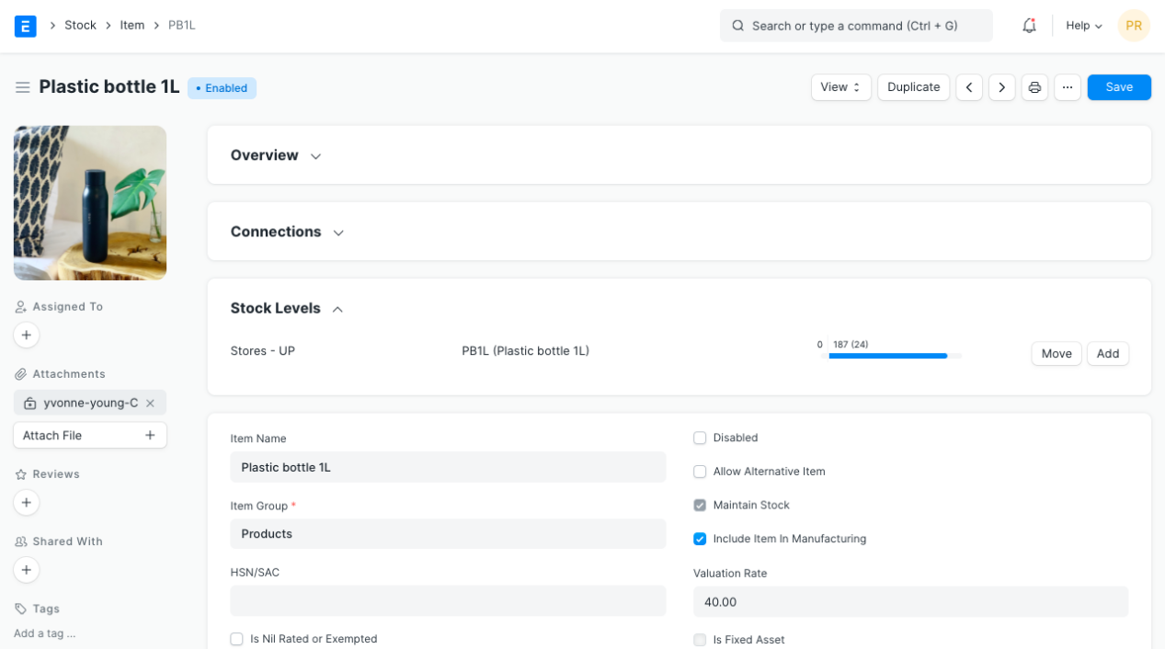

### **Item Properties**

* ****Item Name:**** Item name is the actual name of your product or service.
* ****Item Code:**** Item Code is a short-form to denote your Item. If you have very few Items, it is advisable to keep the Item Name and the Item Code same. This helps new users to recognize and update Item details in all transactions. In case you have a lot of Items with long names and the list runs in hundreds, it is advisable to code. To understand naming Item codes see [Item Codification](https://docs.erpnext.com/docs/v13/user/manual/en/stock/articles/item-codification). You can also generate Item Code based on a [Naming Series](https://docs.erpnext.com/docs/v13/user/manual/en/setting-up/settings/naming-series) by enabling this feature in [Stock Settings](https://docs.erpnext.com/docs/v13/user/manual/en/stock/stock-settings" \l "1-item-naming-by).
* ****Item Group:**** Item Group is used to categorize an Item under various criteria like products, raw materials, services, sub-assemblies, consumables or all Item groups. Create your default Item Group list under Setup > Item Group and pre-select the option while filling your New Item details under [Item Group](https://docs.erpnext.com/docs/v13/user/manual/en/stock/item-group). Item groups can be sub-assemblies, raw materials, etc, or based on your business use case.
* ****Default Unit of Measure:**** This is the default measuring unit that you will use for your product. It could be Nos, Kgs, Meters, etc. You can store all the UOMs that your product will require under Set Up> Master Data > UOM. These can be preselected while filling New Item by using % sign to get a pop up of the UOM list. Visit the [UoM](https://docs.erpnext.com/docs/v13/user/manual/en/stock/uom) page for more details

### **6.2.3 Options when creating an item**

* ****Disabled****: If you disable an Item, it cannot be selected in any transaction.
* ****Allow Alternative Item****: Sometimes when manufacturing a finished good, specific material may not be available. If you tick this, you can create and select an alternative item from the Item Alternative list. To know more, visit the [Item Alternative](https://docs.erpnext.com/docs/v13/user/manual/en/manufacturing/item-alternative) page.
* ****Maintain Stock:**** If you are maintaining stock of this Item in your Inventory, ERPNext will make a stock ledger entry for each transaction of this item. Ensure to keep this option unchecked when creating a non-stock Item (make to order/engineer) or a service.
* ****Include Item in Manufacturing****: This is for raw material Items that'll be used to create finished goods. If the Item is an additional service like 'washing' that'll be used in the BOM, keep this unchecked.
* ****Valuation Rate****: There are two options to maintain valuation of stock. FIFO (first in - first out) and Moving Average. To understand this topic in detail please visit [Item Valuation, FIFO and Moving Average](https://docs.erpnext.com/docs/v13/user/manual/en/stock/articles/calculation-of-valuation-rate-in-fifo-and-moving-average).
* ****Standard Selling Rate****: When creating an Item, entering a value for this field will automatically create an [Item Price](https://docs.erpnext.com/docs/v13/user/manual/en/stock/item-price) at the backend. Entering a value after the Item has been saved will not work. In this case, the Item Price is created from any transactions with the Item. The rate at which you'll sell the item. This will be fetched in Sales Orders and Sales Invoices.
* ****Is Fixed Asset****: Tick this checkbox if this item is a company Asset. Check out the [Asset Module](https://docs.erpnext.com/docs/v13/user/manual/en/asset) to know more.
* ****Auto Create Assets on Purchase****: If Item is a Company Asset, tick this checkbox if you want to auto create assets while purchasing this item through [Purchase Cycle](https://docs.erpnext.com/docs/v13/user/manual/en/buying/purchase-order). Check out the [Asset Page](https://docs.erpnext.com/docs/v13/user/manual/en/asset/asset) to know more.
* ****Allowance Percentage****: This option will be available only when you create and save the item. This is the percent by which you will be allowed to over-bill or over-deliver this Item. If not set, it will select from [Stock Settings](https://docs.erpnext.com/docs/v13/user/manual/en/stock/stock-settings" \l "3-limit-percent).
* ****Uploading an Image****: To upload an image for your icon that will appear in all transactions, save the partially filled form. Only after your file is saved the 'Change' button will appear on the Image icon. Click on Change, then click on Upload, and upload the image.
* For India:
* ****HSN/SAC****: Harmonized System of Nomenclature (HSN) and Service Accounting Code (SAC) for GST. These numbers are defined by the government and different Items fall under different codes. New HSN codes can be added if not present in the list.
* ****Is nil rated or exempted****: For an Item that is under GST, but no tax is applied to it. Eg: Cereals.
* ****Is Non GST****: For an item that is not covered under GST. Eg: petrol.

## **6.2.3. Features**

### **6.2.3.1 Brand and Description**

* ****Brand****: If you have more than one brand save them under Selling > Brand and pre-select them while filling a New Item.
* ****Description****: Description of the item. The text from the Item Code will be fetched by default.

### **6.2.3.2 Barcodes**

Barcodes can be recorded in Items to quickly scan and add them in transactions. In the Barcodes table you can add an Item's [barcode for scanning](https://docs.erpnext.com/docs/v13/user/manual/en/stock/articles/track-items-using-barcode). There are two types of barcodes in ERPNext:

* ****EAN****: The European Article Number is a 13 digit number. EAN is used internationally and recognized by more POS systems.
* ****UPC****: The Universal Product Code is a 12 digit number. UPC is generally used only in USA and Canada.

### **6.2.3.3 Inventory**

* ****Shelf Life In Days****: This is for a product [Batch](https://docs.erpnext.com/docs/v13/user/manual/en/stock/batch). The number of days after which product batch will be unusable. For example, medicines.
* ****End of Life****: For a single item/product, the date after which it'll be completely unusable. That is, the item will be unusable in transactions and manufacturing. For example, you're using plastic crystals for manufacturing Items for the next 5 years after which you want to use plastic beads.
* ****Warranty****: To track a warranty period, it is necessary that the Item is serialized. When this Item is delivered, the delivery date and the expiry period is saved in the Serial Number master. Through the serial number master, you can track the warranty status.
* A warranty period is a time period in which a purchased product may be returned or exchanged.
* ****Weight UOM****: The Unit of Measure for the item. This can be Nos, Kilo, etc. The Weight UoM which you use internally can be different from the purchase UoM.
* ****Weight Per Unit****: The actual weight per unit of the item. Eg: 1 kilo biscuits or 10 biscuits per pack.
* ****Default Material Request Type****: When you create a new Material Request for this item, the field set here will be selected by default in the new Material Request. This is also known as an 'indent'.
* ****Valuation Method****: Select the Valuation Method whether FIFO or Moving Average. Read [Item Valuation methods](https://docs.erpnext.com/docs/v13/user/manual/en/stock/articles/calculation-of-valuation-rate-in-fifo-and-moving-average) to know more.

### **6.2.3.4 Automatic Reordering**

When the stock of an item dips under a certain quantity, you can set an automatic reorder under 'Auto Reorder' section. This should be enabled in [Stock Settings](https://docs.erpnext.com/docs/v13/user/manual/en/stock/stock-settings" \l "9-automatic-material-request). This will raise a [Material Request](https://docs.erpnext.com/docs/v13/user/manual/en/stock/material-request) for the Item. The user with roles Purchase Manager and Stock Manager will be ****notified**** when the Material Request is created.

* ****Check in (group)****: In which group warehouses to check the quantity of the item.
* ****Request for****: Which warehouse to stock the item reorder.
* ****Re-order Level****: When this quantity is reached, the reorder will be triggered. Re-order level can be determined based on the lead time and the average daily consumption. For example, you can set the reorder level of Motherboard at 10. When only 10 Motherboards are remaining in stock, the system will either automatically create a Material Request in your ERPNext account.
* ****Re-order Qty****: The number of units to be reordered so that the sum of ordering cost and holding cost is at its minimum. The re-order quantity is based on the 'Minimum Order Qty' specified by the supplier and many other factors.

For example, If reorder level is 100 items, your reorder quantity may not necessarily be 100 items. The Reorder quantity can be greater than or equal to the reorder level. It may depend upon lead time, discount, transportation and average daily consumption.

* ****Material Request Type****: The [Material Request](https://docs.erpnext.com/docs/v13/user/manual/en/stock/material-request) type with which the stock will be reordered. This depends whether you buy the Item, manufacture it yourself or transfer it between Warehouses.

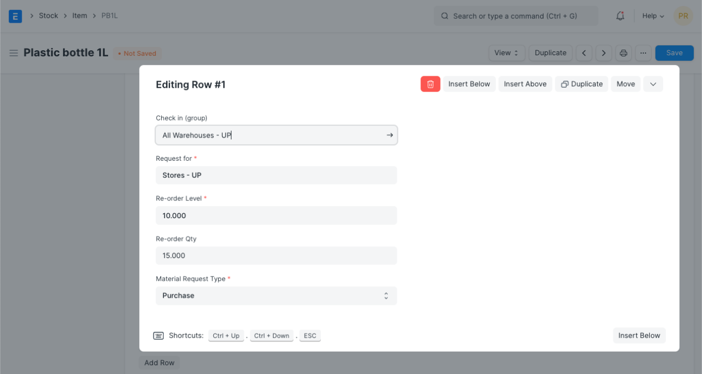

### **6.2.3.5 Multiple Units of Measure**

You can add alternate UoMs for an Item. If the default UoM in which you sell is numbers (NoS) but you receive it in Kilos, you can set an additional UoM with an appropriate conversion factor. For example, 500 Nos of screws = 1 Kilogram, so select Kilogram/Litre as UOM and set the conversion factor as 500. To know more about selling in different UoM.

### **6.2.3.6 Serial Numbers**

With Serial Numbers, you can track warranty and returns. In case any individual Item is recalled by the supplier the number system helps to track individual Item. The numbering system also manages expiry dates.

Please note that if you sell your items in thousands, and if the items are very small like pens or erasers, you need not serialize them.

In ERPNext, you will have to mention the Serial Number in some accounting entries. If your product is not a big consumer durable Item, if it has no warranty and has no chances of being recalled, avoid giving serial numbers.

### **6.2.3.7 Batches**

A set of Items can be manufactured in batches. This is useful for moving the batch and associate an expiry date with a certain batch.

****Has Batch No****: Options for batch number, expiry date, and retaining sample stock will be revealed on ticking this checkbox. You cannot activate this if there is any pre-existing transaction for this item. If this is disabled, you'll have to enter the serial numbers manually for every transaction.

****Batch Number Series****: Prefix that'll be applied to batch numbers. If you set 5x1SCR, then the first batch will be named like 5x1SCR00001 on first transaction/manufacture.

****Automatically Create New Batch****: If the batch number is not mentioned in transactions, then they will be automatically created according to a format like AAAA.00001. If you always want to manually create a batch number for this item, leave this field blank. This setting will override 'Naming Series Prefix' in Stock Settings. Batch numbers can be set to be generated automatically if you manufacture the Items or can be entered manually if it comes from an external manufacturer.

****Has Expiry Date****: If you tick this, the batch number will be created according to the expiry date. The expiry dates can be set in the 'Batch' master.

****Retain Sample****: To retain a minimum number of sample stock of the item. You need to set a Sample Retention Warehouse in Stock Settings for this.

****Has Serial No****: This is similar to Batch Number Series, it'll be created when you make transactions/manufacture. If you set Serial Number Series as AA, then on the first transaction a serial number like AA00001 will be created.

### **6.2.3.8 Item Defaults**

In this section, you can define Company-wide transaction-related defaults for this Item.

* ****Default Warehouse:**** This is the Warehouse that is automatically selected in your transactions with this item.
* ****Default Price List:**** Whether Standard Selling or Standard Buying. Likewise, you can also set the purchasing and selling default accounts
* ****Supplier****: If a default supplier is set, this supplier will be selected for new purchase transactions.
* ****Default Expense Account:**** It is the account in which cost of the Item will be debited.
* ****Default Income Account:**** It is the account in which income from selling the Item will be credited.
* ****Default Cost Center:**** It is used for tracking expense for this Item.

### **6.2.3.9 Purchase, Replenishment Details**

* ****Default Purchase Unit of Measure****: The default UoM that will be used in Purchase transactions.
* ****Minimum Order Qty****: The minimum quantity required for purchase transactions like Purchase Orders. If set, the system will not let you proceed with the purchase transaction if the item quantity in the purchase transaction is lesser than the quantity set in this field.
* ****Safety Stock****: “Safety Stock” is used in the report “Itemwise Recommended Reorder Level”. Based on Safety Stock, average daily consumption and the lead time, the system suggests Reorder Level of an item.
* Reorder Level = Safety Stock + (Average Daily Consumption * Lead Time)
* ****Last Purchase Rate****: The rate at which you last purchased this item using a Purchase Invoice will be displayed here.
* ****Is Purchase Item:**** If unticked, you won't be able to use this item in purchase transactions.
* ****Is Customer Provided Item:**** Checked if Item is provided by a customer and received through ****Stock Entry > Material Receipt****. If Checked, ****Customer**** field is Mandatory as the default customer for ****Material Request****.
* ****Lead time days:**** Lead time days are the number of days between ordering the Item and it to reach the Warehouse.

### **6.2.3.10 Sales Details**

* ****Grant Commission****: Grant a commission to [Sales Person](https://docs.erpnext.com/docs/v13/user/manual/en/CRM/sales-person) and [Sales Partner](https://docs.erpnext.com/docs/v13/user/manual/en/selling/sales-partner) when this item is sold. If disabled, the sales generated by this item will be ignored in the calculation of commission.
* ****Default Sales Unit of Measure****: The default UoM that'll be fetched for sales transactions.
* ****Max Discount (%)****: You can define the maximum discount in % to be applied to an item. Eg: if you set 20%, you cannot sell this item with a discount greater than 20%.
* ****Is Sales Item****: If unticked, you won't be able to use this item in sales transactions.

### **6.2.3.11 Item Tax**

These settings are required only if a particular Item has a different tax rate than the rate defined in the standard tax Account.

You need to create a new 'Item Tax Template' or choose an existing one. For example, if you have a tax Account, “VAT 14%” and this particular Item is exempted from tax, then you select “VAT 14%” in the first column, and set “0” as the tax rate in the second column.

### **6.2.3.12 Inspection Criteria**

* ****Inspection Required before Purchase****: If an inspection is mandatory before the item is purchased, i.e., before you generate Purchase Receipt, tick this checkbox.
* ****Inspection Required before Delivery****: If an inspection is required at the time of delivery from your Supplier is mandatory for this Item, tick this checkbox. That is, before you generate a Delivery Note.

### ****Quality Inspection Template****: If a Quality Inspection is prepared for this Item, then this template of criteria will automatically be updated in the Quality Inspection table of the Quality Inspection. Examples of **3.18 Manufacturing**

* ****Default BOM****: The default [Bill of Materials](https://docs.erpnext.com/docs/v13/user/manual/en/manufacturing/bill-of-materials) used to manufacture this Item.
* ****Supply Raw Materials for Purchase****: If you're subcontracting to a vendor, you can choose to provide them with the raw materials to manufacture the item using the default BOM.
* ****Manufacturer:**** Select the Manufacturer who manufactured this item.
* ****Manufacturer Part Number:**** Enter the manufacturer part number that the manufacturer has assigned to this item. Criteria are: Weight, Length, Finish, etc.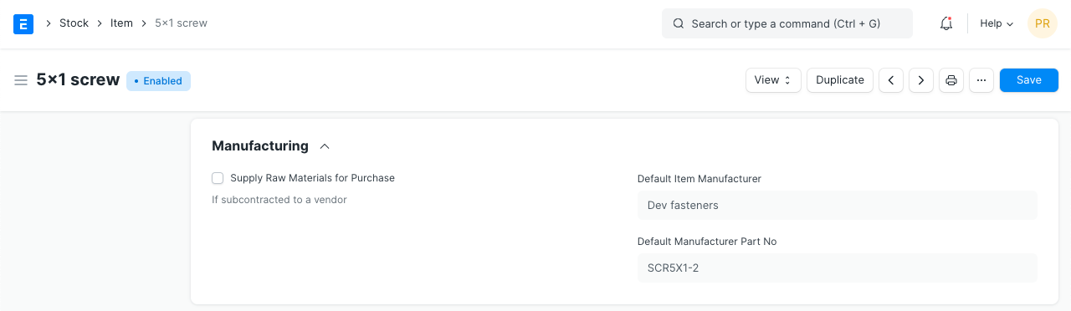
* The manufacturer details appear after you've created an 'Item Manufacturer' from the dashboard and selected that record as default. Here, add details for:
* Item Code
* Enter the manufacturer name
* Enter the part number the manufacturer uses to identify this item
* Select 'Is Default' to show the manufacturer and part number in the Item record

**6.3 Item Price:**

**Item Price is the record in which you can log the selling and buying rate of an item.**

## **6.3.1. How to create Item Price**

1. There are two ways to reach a new Item Price form:

Home > Retail-Billing System>Reports & Masters > Masters  **> Item Price > New**.

1. Select the Item. The name, UoM and description will be fetched.
2. Select the Price List whether Selling/Buying price or any other price list you may have created.
3. Enter the actual rate in the Rate field.
4. Save.

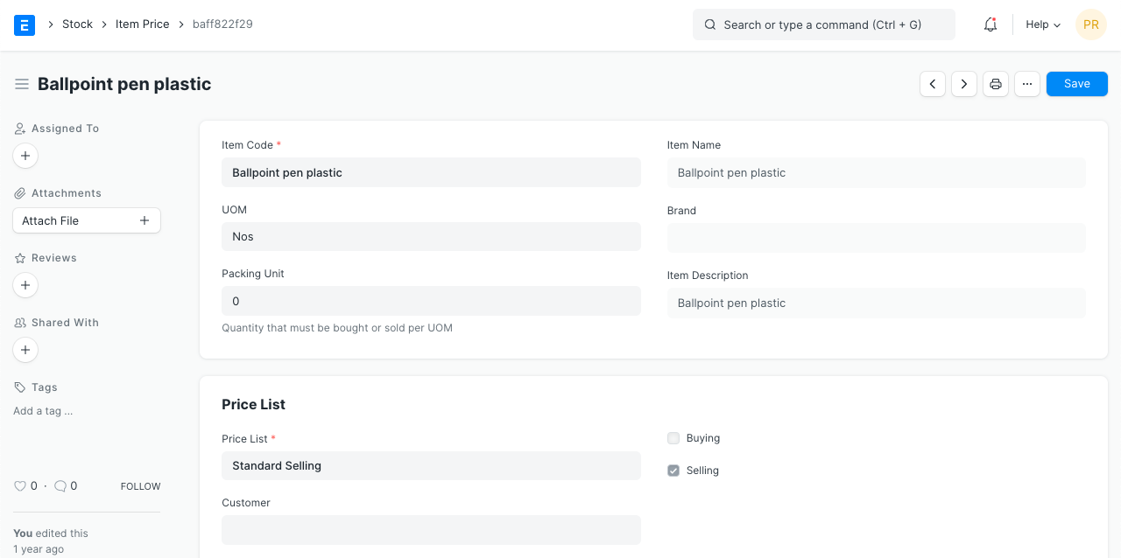

### **6.3.2 Selecting the Price List**

You can create multiple Price Lists for one Item in ERPNext to track Selling and Buying Price of an Item separately. Also if the Item's selling prices change based on Territory or due to other criteria, you can create multiple Selling Price Lists for it.

On selection of Price List, its currency and applicability whether for selling/buying or both will be fetched as well. To have Item Price fetching in the sales or purchase transaction, you should have 'Price List' selected in the transaction under Currency and Price List.

# **6.4 Pricing Rule**

**A Pricing Rule defines the discount/pricing rules that apply based on set conditions.**

A Pricing Rule has many options using which you can control the pricing of an Item. Filters like quantity, date, groups, and other conditions can be set.

A Pricing Rule is somewhat similar to a [Tax Rule](https://docs.erpnext.com/docs/v13/user/manual/en/accounts/tax-rule).

Following are the few cases which can be addressed using Pricing Rule:

* As per a promotional sale policy, if the Customer purchases more than 10 units of an item, he enjoys 20% discount.
* For Customer "XYZ", the selling price for the specific Item should be updated as ###.
* Items categorized under specific Item Group have same selling or buying price.
* Customers belonging to specific Customer Group should get ### selling price, or % of Discount on Items.
* Supplier categorized under specific Supplier Group should have ### buying rate applied.

To have Discount and Price List Rate for an Item auto-applied, create Pricing Rules for it.

To access the Pricing Rule list, go to:

Home > Retail-Billing System>Reports & Masters > Masters > Pricing Rule.

## **6.4.1Prerequisites**

Before creating and using a Pricing Rule, it is advisable to create the following first:

1. [Item](https://docs.erpnext.com/docs/v13/user/manual/en/stock/item)
2. [Item Group](https://docs.erpnext.com/docs/v13/user/manual/en/stock/item-group)
3. [Customer](https://docs.erpnext.com/docs/v13/user/manual/en/CRM/customer)
4. [Supplier](https://docs.erpnext.com/docs/v13/user/manual/en/buying/supplier)

## **6.4.2. How to create a Pricing Rule**

1. Go to the Pricing Rule list and click on New.
2. Set a title for the rule.
3. Select what to Apply On from Item Code, Item Group, Brand, or Transaction.
4. Select whether you want to apply Price discount or Product discount. If you want to give free products then select the product discount.

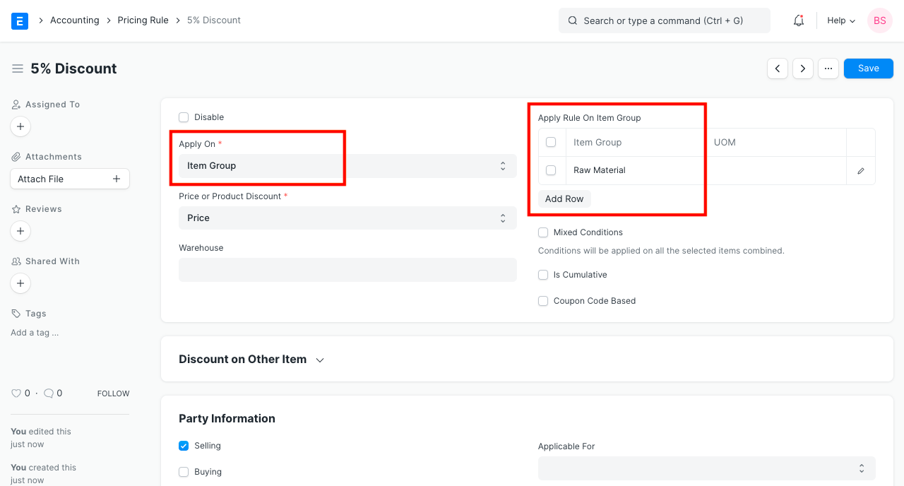

1. For a single item, select Item Code and select the items.
2. If you want Pricing Rule to be applied on all the items, select 'Item Group' and select ****All Item Group**** (parent Item Group).
3. Set the discount/price to be applied.
4. Save.

# **6.5 Warehouse**

**A warehouse is a commercial building for storage of goods. Warehouses are used by manufacturers, importers, exporters, wholesalers, transport businesses, customs, etc.**

They are usually large plain buildings in industrial areas of cities, towns, and villages. They mostly have loading docks to load and unload goods from trucks.

The terminology of 'Warehouse' in ERPNext is a bit broader though and maybe can be regarded as "storage locations". You can create a sub-Warehouse which could be a shelf inside your actual location.

This can become quite a detailed Tree like the following:

Home > Retail-Billing System>Reports & Masters > Masters > Warehouse

## **6.5.1. How to create a Warehouse**

1. Go to the Warehouse list, click on New.
2. Enter a name for the Warehouse.
3. Set/check the Parent Warehouse. If you tick on 'Is Group', you can create sub-Warehouses under this group Warehouse.
4. Save.

Warehouses are saved with their respective Company’s abbreviations. This facilitates identifying which Warehouse belongs to which company at a glance.

## **6.5.1.1 Additional options when creating a Warehouse**

****Account****: Set a default account here for all transactions with this Warehouse. Setting this account will show transactions from this Warehouse in the Accounting Ledger. ****Warehouse Type****: You can create a Warehouse Type to classify Warehouses. For example, Supplier Warehouses, Stock Warehouses, WIP Warehouses, Rooms, etc. can be tagged. This classification is useful when generating reports or in certain stock transactions.

### **6.5.1.2 After Saving**

After saving a Warehouse, you'll see the following options:

* ****Stock Balance****: This will open the Stock Balance report to display the quantity, valuation, balance, etc.
* ****General Ledger****: This will open the General Ledger to display the accounting transactions.
* ****Non-Group to Group****: If the Warehouse is a Non-Group Warehouse, i.e. cannot contain other Warehouses under it, this button will make this a Group Warehouse.

****6.7 Chart of Accounts****

**The Chart of Accounts is the blueprint of the accounts in your organization.**

The overall structure of your Chart of Accounts is based on a system of double entry accounting that has become a standard all over the world to quantify how a company is doing financially.

Chart of Accounts is a tree view of the names of the Accounts (Ledgers and Groups) that a Company requires to manage its books of accounts. ERPNext sets up a simple chart of accounts for each Company you create, but you can modify it according to your needs and legal requirements.

For each company, Chart of Accounts signifies the way to classify the accounting entries, mostly based on statutory (tax, compliance to government regulations) requirements.

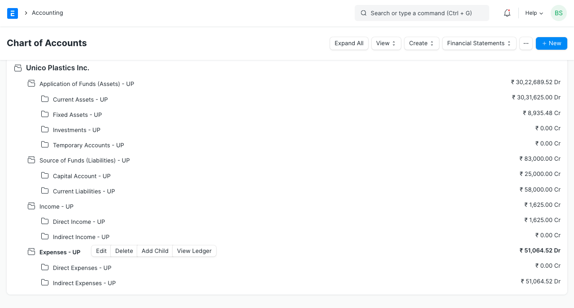

## **6.7.1. How to Create/Edit Accounts**

ERPNext comes with a standard set Chart of Accounts. Instead of creating/modifying, you can also use the [Chart of Accounts Importer](https://docs.erpnext.com/docs/v13/user/manual/en/setting-up/chart-of-accounts-importer) tool. Note that the existing Chart of Accounts will be overwritten when this tool is used.

1. Go to the Chart of Accounts list. Here you can open group accounts which contain other accounts. There are options to “Add Child” in an account, Edit or Delete the account.
2. The option to create a child account will only appear if you click on a Group (folder) type Account.
3. Enter a name for the account.
4. Enter a number for the account.
5. Tick 'Is Group' if you want this to be a group account which can contain other accounts.
6. Select the Account Type. Selecting this is important as some fields allow selecting only specific type of accounts.
7. Change the currency if this account will be used for transactions with different currency. By default, it's the Company's currency. To know more, visit the [Multi Currency Accounting](https://docs.erpnext.com/docs/v13/user/manual/en/accounts/multi-currency-accounting) page.
8. Click on ****Create New****.

## **6.7.2. Account Types**

Account types are mainly classified as income, expense, asset, or liability.

### **6.7.2.1 Balance Sheet Accounts**

Balance Sheet accounts are 'Application of Funds (Assets)' and 'Sources of Funds (Liabilities)' that signifies the net-worth of your company at any given time. When you begin or end a financial period, all the Assets are equal to the Liabilities.

All the accounts under Balance Sheet accounts represent an asset owned by the company like "Bank Account", "Land and Property", "Furniture" or a liability (funds that the company owes to others) like "Owners funds", "Debt" etc.

Two special accounts to note here are Accounts Receivable (money you have to collect from your Customers) and Accounts Payable (money you have to pay to your Suppliers) under Assets and Liabilities respectively.

### **6.7.2.2 Profit and Loss Accounts**

Profit and Loss is the group of 'Income' and 'Expense' accounts that represent your accounting transactions over a period.

Unlike Balance Sheet accounts, Profit and Loss accounts (or PL accounts) do not represent net worth (Assets), but rather represent the amount of money spent and collected in servicing customers during the period. Hence, at the beginning and end of your Fiscal Year, they become zero.

# **6.8 Sales Invoice**

**A Sales Invoice is a bill that you send to your Customers against which the Customer makes the payment.**

Sales Invoice is an accounting transaction. On submission of Sales Invoice, the system updates the receivable and books income against a Customer Account.

To access the Sales Invoice list, go to:

Home > Retail-Billing System>Reports & Masters > Masters > Sales Invoice

## **6.8.1. Prerequisites**

Before creating and using a Sales Invoice, it is advised to create the following first:

* Item
* Customer

## **6.8.2. How to create a Sales Invoice**

A Sales Invoice is usually created from a Sales Order or a Delivery Note. The Customer's Item details will be fetched into the Sales Invoice. However, you can also create a Sales Invoice directly, for example, a POS invoice.

To fetch the details automatically in a Sales Invoice, click on the ****Get Items from****. The details can be fetched from a Sales Order, Delivery Note, or a Quotation.

For manual creation, follow these steps:

1. Go to the Sales Invoice list and click on New.
2. Select the Customer.
3. Set the Payment Due Date.
4. In the Items table, select the Items and set the quantities.
5. The prices will be fetched automatically if [Item Price](https://docs.erpnext.com/docs/v13/user/manual/en/stock/item-price) is added, else add a price in the table.
6. The posting date and time will be set to current, you can edit after you tick the checkbox below Posting Time to make a backdated entry.
7. Save and Submit.

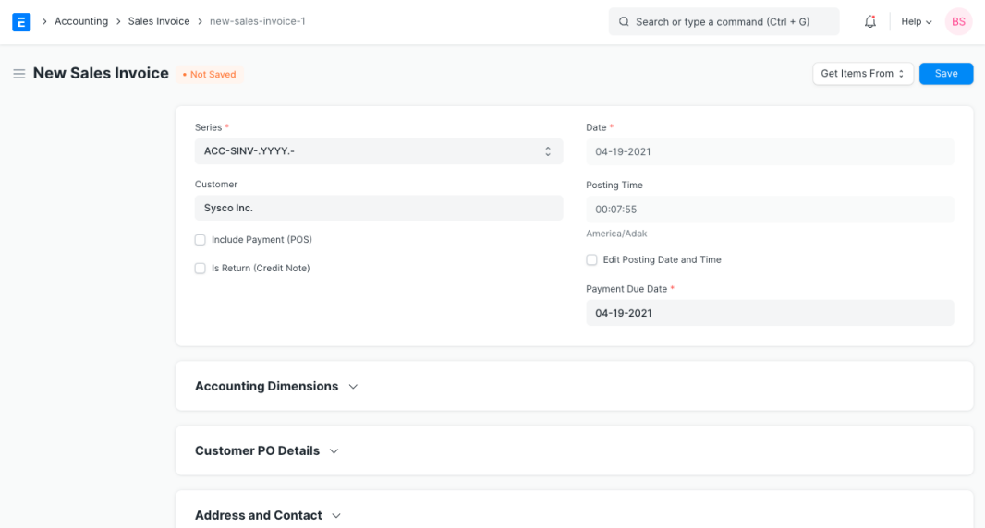

### **6.8.2.1 Additional options when creating a Sales Invoice**

* ****Include Payment (POS)****: If this invoice is for retail sales / Point of Sale. [Know more here](https://docs.erpnext.com/docs/v13/user/manual/en/accounts/sales-invoice" \l "324-pos-invoices).
* ****Is Return Credit Note****: Tick this if the customer has returned the Items.

### **6.8.2.2 Statuses**

These are the statuses that are auto-assigned to Sales Invoice.

* ****Draft****: A draft is saved but yet to be submitted.
* ****Submitted****: The invoice is submitted to the system and the general ledger has been updated.
* ****Paid****: Customer has made the payment and a [Payment Entry](https://docs.erpnext.com/docs/v13/user/manual/en/accounts/payment-entry) has been submitted.
* ****Unpaid****: Invoice is generated but payment is pending but within the payment due date.
* ****Overdue****: Payment is pending beyond the payment due date.
* ****Canceled****: The Sales Invoice is canceled due to any reason. Once an invoice is canceled, it's impact on Account and Stock is undone.
* ****Credit Note Issued****: The Item is returned by the Customer and a [Credit Note](https://docs.erpnext.com/docs/v13/user/manual/en/accounts/credit-note) is created against this invoice.
* ****Return****: It is assigned to Credit Note created against the original Sales Invoice. Though you can also create a standalone Credit Note.
* ****Unpaid and Discounted****: Payment is pending and any ongoing subscription has been discounted using [Invoice Discounting](https://docs.erpnext.com/docs/v13/user/manual/en/accounts/invoice_discounting).
* ****Overdue and Discounted****: Payment is pending beyond the payment due date and any ongoing subscription has been discounted using [Invoice Discounting](https://docs.erpnext.com/docs/v13/user/manual/en/accounts/invoice_discounting).